# CS 255 System Design Document Template

## UML Diagrams

### UML Use Case Diagram

*[In Module Six, you were asked to complete a use case diagram based on your system design. If you would like to make any adjustments to your diagram, please do so. Please insert your use case diagram here. Check to make sure that you included appropriate components and symbols and that your design meets the client’s needs.]*

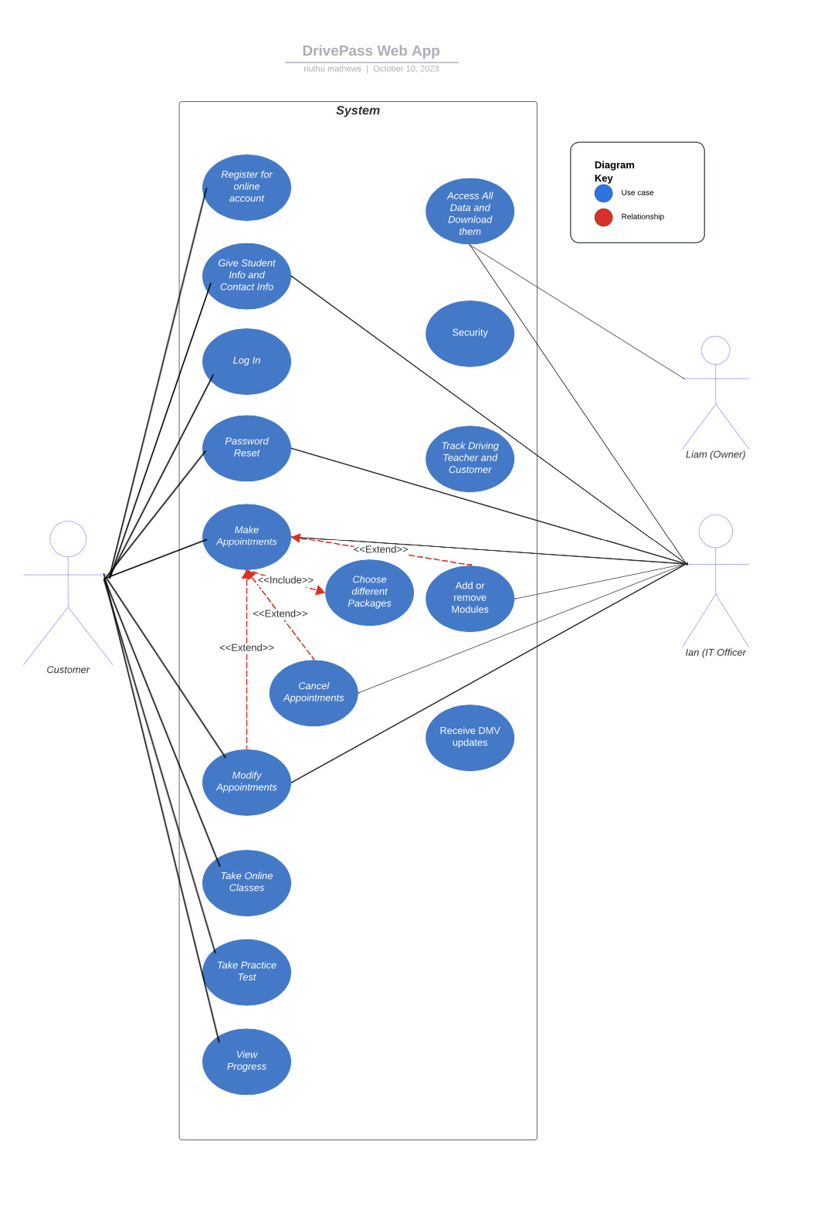

### UML Activity Diagrams

*[You were asked to choose* ***two*** *use cases and create* ***two*** *activity diagrams, one for each use case. Please insert* ***both*** *of your activity diagrams here. Check to make sure that you included appropriate components and symbols and that your design meets the client’s needs.]*

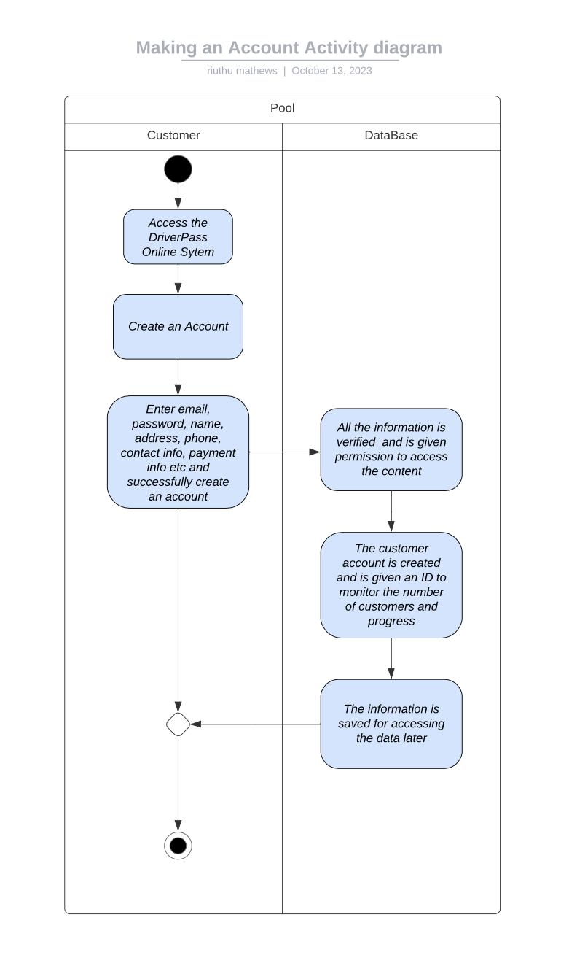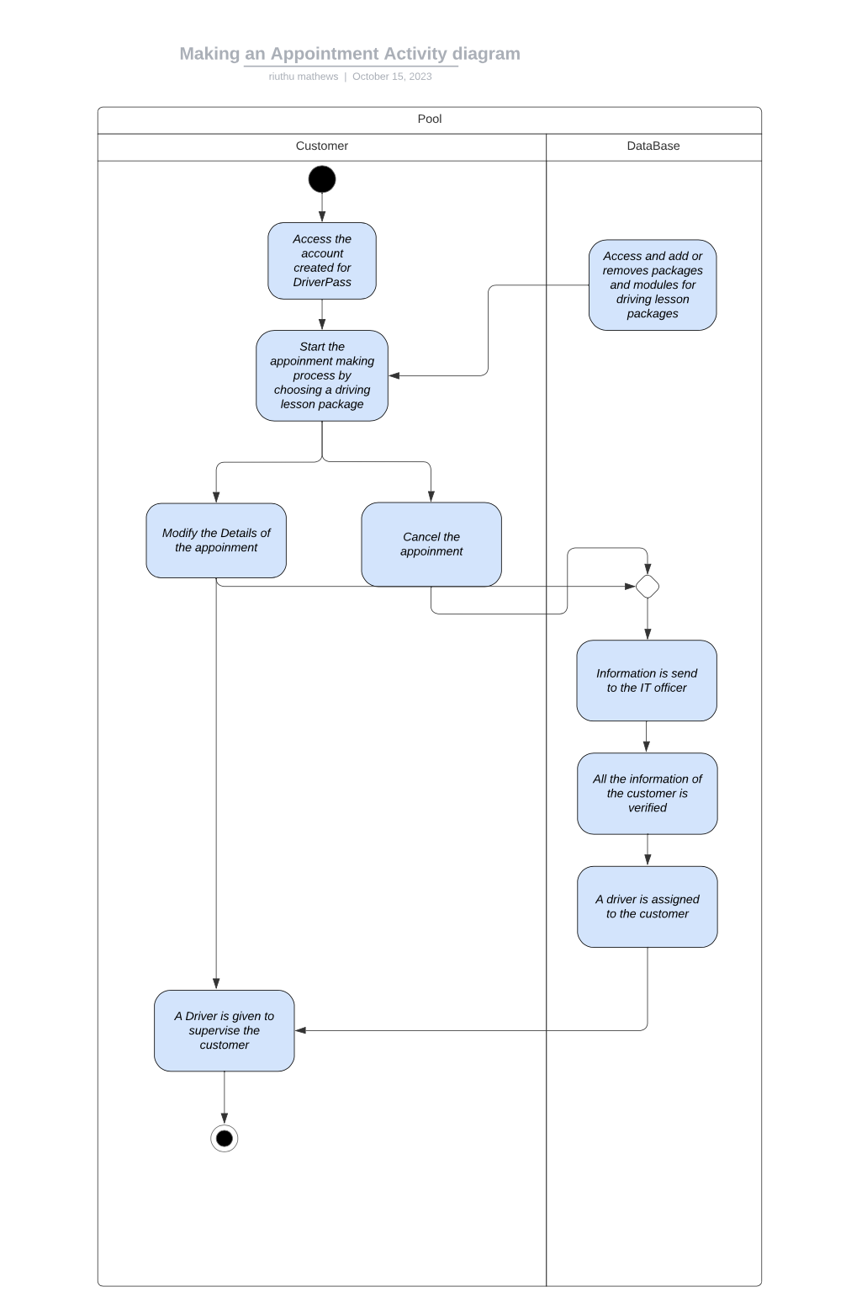

### UML Sequence Diagram

*[You were asked to create a sequence diagram based on* ***one*** *of the use cases you chose. Please insert your sequence diagram here. Check to make sure that you included appropriate components and symbols and that your design meets the client’s needs.]*

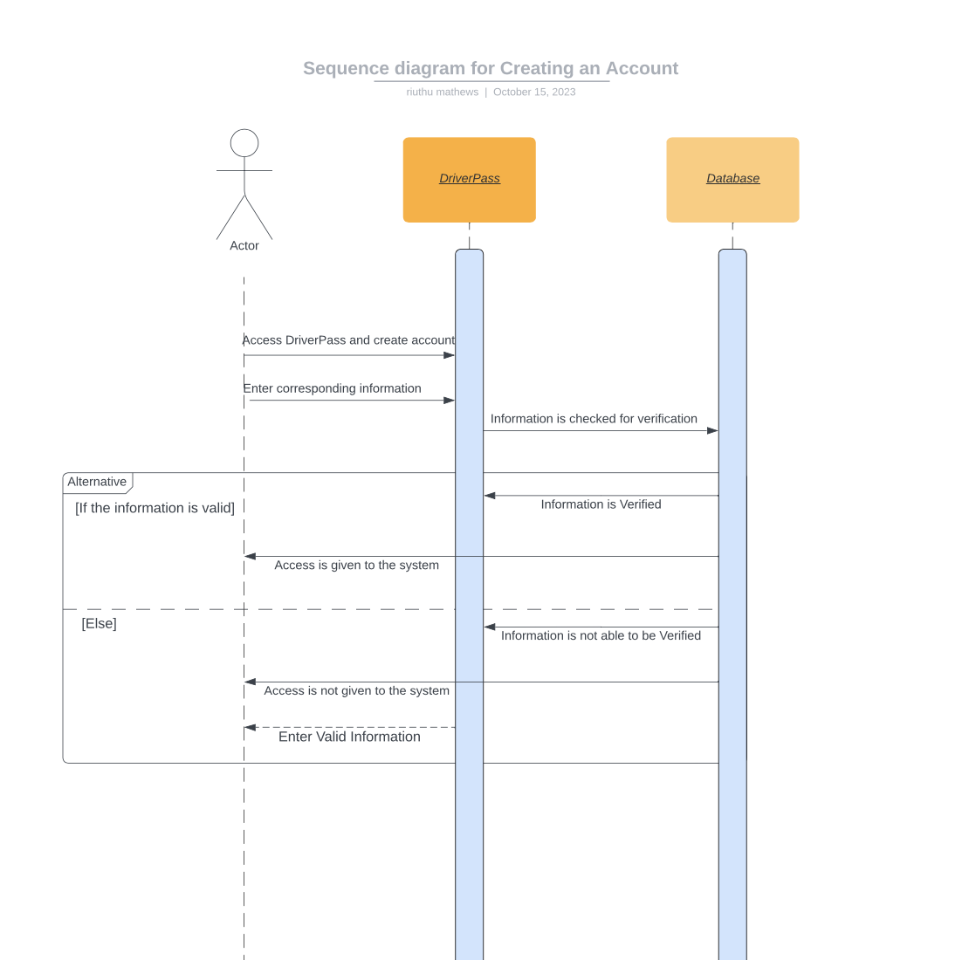

### UML Class Diagram

*[You were asked to create a class diagram based on the different classes and attributes needed for your system design. You are* ***not*** *required to include methods, but you may if you wish. Please insert your class diagram here. Check to make sure that you included appropriate components and symbols and that your design meets the client’s requirements.]*

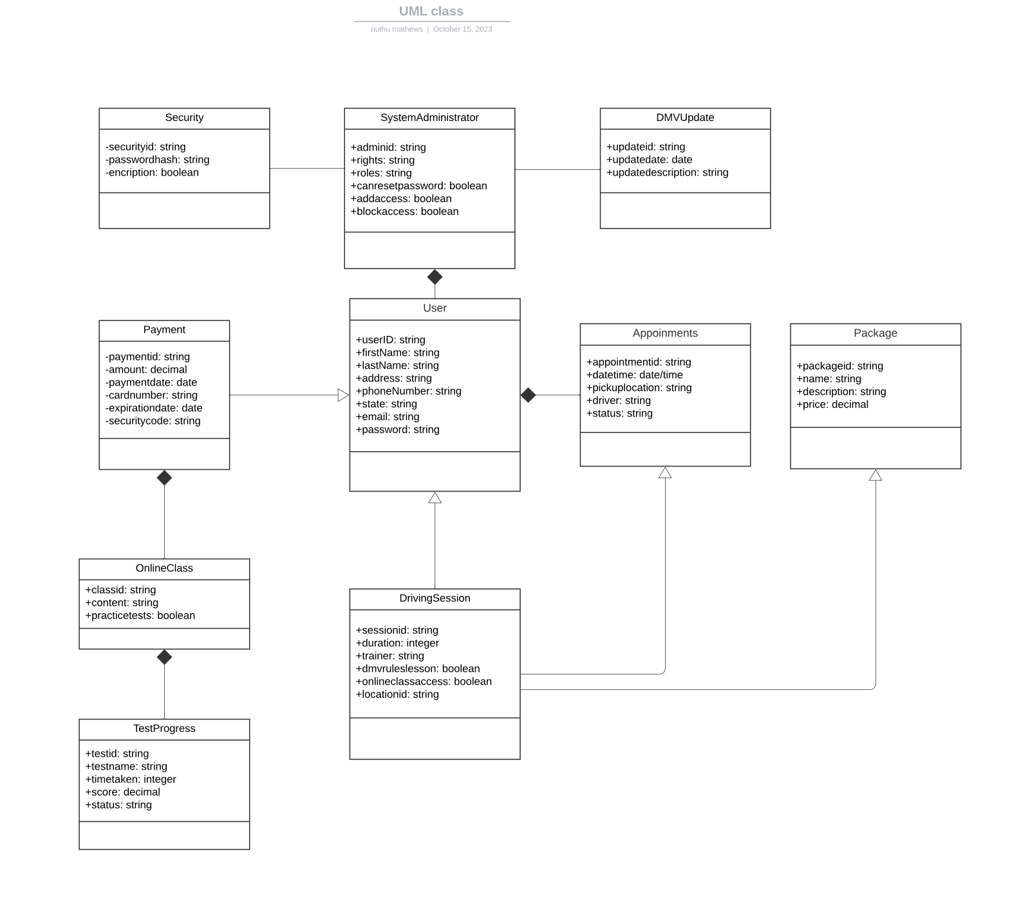

## Technical Requirements

*[Based on the diagrams you have created, describe the technical requirements of your system. These requirements should address the required hardware, software, tools, and infrastructure necessary for your system design.]*

The technical requirements for the DriverPass system may include hardware, software, tools, and infrastructure for a successful deployment of the system. When describing the hardware requirements, servers are necessary to host the system, furthermore, databases are also required to store and to make decision. Expanding the hardware, a storage systems for user data and system backups. As far as software requirements, web development frameworks are the preferred choice for front-end development; For backend development, the popular language now, PHP, can be utilized by the DriverPass system for backend deployment. Security software and encryption tools are also necessary to protect users and employee’s data. And to cooperate with DMV regulations the system also needs DMV data integration tools. The tools and Infrastructure requirement may warrant an Integrated Development Environments (IDEs) for software development part of the system. UML modeling tools, like lucid charts also may be beneficial for creating diagrams. A cloud infrastructure such as azure or google cloud could be responsible for scalability part of the system. These are the minimal technical requirements to ensure the reliability, safety, and security of the DriverPass system. By meeting these requirements, the system can deliver the requirements outlined in the meeting with the DriverPass.